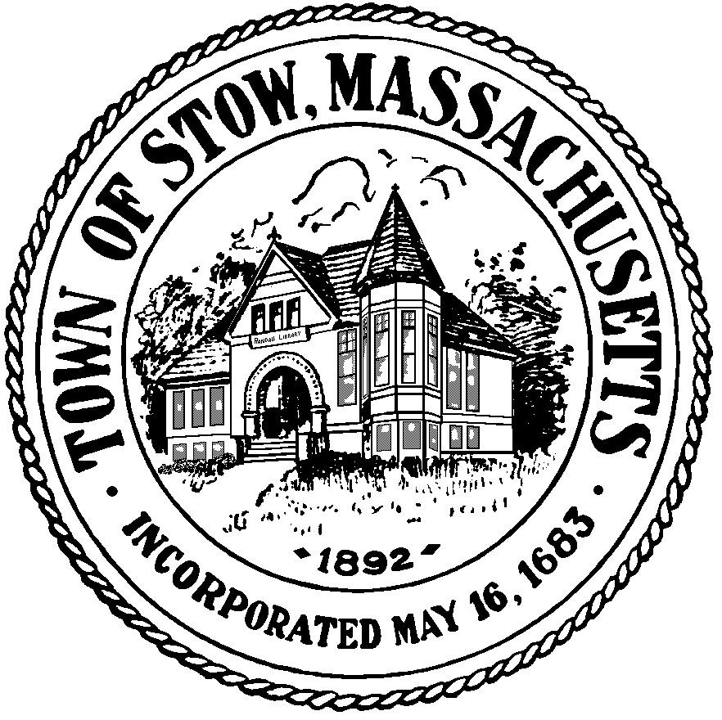

Town of Stow

community preservation committee

Agenda for Monday, January 23 2012 7:30pm, Town Building
- MEMBER UPDATE
- BILLS & MINUTES
- UPDATE FROM STOW COMMUNITY/ELDERLY HOUSING COMMITTEE
REGARDING THE PILOT GROVE II AND PLANTATION II PROJECTS
- LETTER OF COMMITMENT FOR PILOT GROVE II PROJECT
- HISTORIC DOCUMENT PRESERVATION PROJECT DISCUSSION
LINDA HATHAWAY TOWN CLERK
- ANNUAL REPORT
- NEW BUSINESS

